|  |  |
| --- | --- |
|  | **FPT ACADEMY INTERNATIONAL**  **FPT – APTECH COMPUTER EDUCATION** |

**Centre Name: ACE-HCMC-2-FPT.**

**Address: 590 Cach Mang Thang 8, District 3, Ho Chi Minh City, Viet Nam.**

Cinestar

Project Report Semester 4

|  |  |  |
| --- | --- | --- |
| **Supervisor** | Ngo Phuoc Nguyen | |
| **Batch** | T1.1910.M1 | |
| **Group** | 3 | |
| **Serial No.** | **Student Name** | **Enrollment Number** |
| 1. | Trần Kim Đạt | Student1215622 |
| 2. | Nguyễn Doãn Đại | Student1226493 |
| 3. | Nguyễn Thanh Huy | Student1218317 |

**Aug – 2021**

**This is to certify that**

**Mr./Ms.:**

TRAN KIM DAT

NGUYEN DOAN DAI

NGUYEN THANH HUY

**Has successful design & developed:** Project: CINESTAR

**Submitted by:** TRAN KIM DAT

**Date of issue:** Aug– 2021

**Authorized Signature:**

**_______________________________________**

# **SYSTEM REQUIREMENT SPECIFICATION**

## **Hardware**

### Web Server

|  |  |
| --- | --- |
| Processor | Intel Core i5 or higher. |
| Memory | 4 GB RAM or greater. |
| Modem/ADSL | Connecting to internet 24/24 |

### Client

|  |  |
| --- | --- |
| Processor | Intel Core i3 or higher. |
| Memory | 2 GB RAM or greater. |
| Monitor | Super VGA (1024x768) or higher resolution |
| Modem/ADSL | Connecting to internet |

## **Software:**

### Web Server

|  |  |
| --- | --- |
| Operation System | Windows 7 or higher |
| Browser | Chrome version 35 or Microsoft  Edge. |
| Database | SQl server 18 |
| Software | Internet Information Service |
| JAVA |
| NetBean |
| GlassFish |
| Intellij IDEA (api) |
| Android Studio |

### Client

|  |  |
| --- | --- |
| Operation System | Windows 7 or higher |
| Browser | Chrome version 35 or Microsoft Edge. |

**2.1 Development software**

* Microsoft Windows 10
* NetBean 8.2
* SQL Server 18
* Android Studio
* Intellij IDEA (api)
* Google Chrome or Microsoft Edge

**2.2 Technology**

* JavaEE
* API(Spring boot)
* Android
* Html , Css
* jQuery
* Javascript
* ajax
* Bootstrap
* JSP
* Servlet
* Facebook api
* Google api
* Zalo api
* Websocket
* Heremap api
* Barcode,qrcode
* .vchat

Chatbot(vchat)

**Android studio**

**Retrofit api**

# WEB SITE

## Step 1 Install netbean and run script sql

* 1. Download netbean 8.2, jdk 1.8.0_291, glassfish 4.0, android studio.

Netbean 8.2:   
_Link 1:<https://taimienphi.vn/download-netbean-ide-5221/8.2-phien-ban>.  
Down and unzip(if need)

_Link 2:  
<https://drive.google.com/file/d/1UXZzvayudtxsIulX1H2ByrKvZ4JDmcDA/view>

(netbean-ide_82(1).exe.zip inside folder project ) .Unzip

_Link 3: <https://github.com/kimdat/project.git>  
(netbean-ide_82.exe.zip inside folder project ) .Unzip

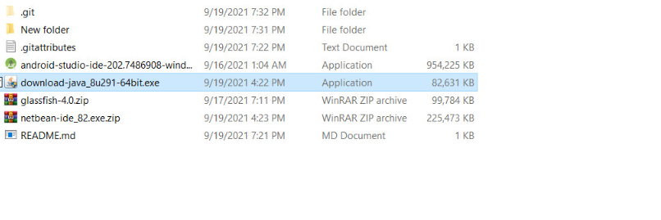

Jdk 1.8.0_291:   
_Link 1:<https://taimienphi.vn/download-java-runtime-environment-221/8-update-291-64bit-phien-ban>   
. Unzip(if need)

_Link 2: <https://drive.google.com/file/d/1UXZzvayudtxsIulX1H2ByrKvZ4JDmcDA/view>

(download-java_8u291 inside folder project )

_Link 3: <https://github.com/kimdat/project.git>  
(download-java_8u291 inside folder project )



glassfish 4:

_Link 1: [https://drive.google.com/file/d/1UXZzvayudtxsIulX1H2ByrKvZ4JDmcDA/view](https://drive.google.com/file/d/1UXZzvayudtxsIulX1H2ByrKvZ4JDmcDA/view%20) (glassfish-4.0 zip inside folder project).Unzip

_Link 2 : <https://github.com/kimdat/project.git>  
(glassfish-4.0 zip inside folder project).Unzip



Anrdoird studio:

_Link 1: <https://drive.google.com/file/d/1UXZzvayudtxsIulX1H2ByrKvZ4JDmcDA/view>  
.( android-studio-ide-202.7486908-windows.exe inside folder project).

_Link 2:

https://developer.android.com/studio?gclid=Cj0KCQjwv5uKBhD6ARIsAGv9a-ya-RPSZ3ql7p6ioMA21U7hnyjLyv2UyJdf43S5TUEHZb5GOGOrVycaAutcEALw_wcB&gclsrc=aw.ds

Link 3: <https://github.com/kimdat/project.git>  
( android-studio-ide-202.7486908-windows.exe inside folder project).



Warning:When you clone from github, please down and install git large file store. Follow the instruction at <https://git-lfs.github.com/>.After down and install ,use git lfs clone instead of git clone. Please wait. If can’t clone fully, please remove folde project and use git lfs clone again.Clonse success when dowling LFS object:100%

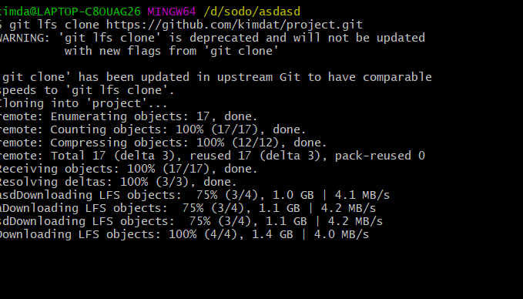

1.2 Open netbean 8.2 exe, wait and then click next

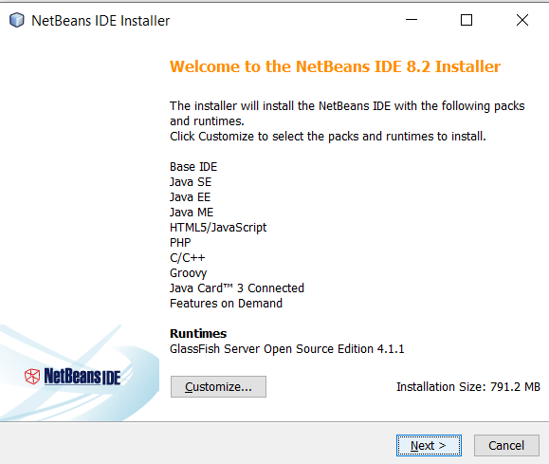

1.3 Click accept and next

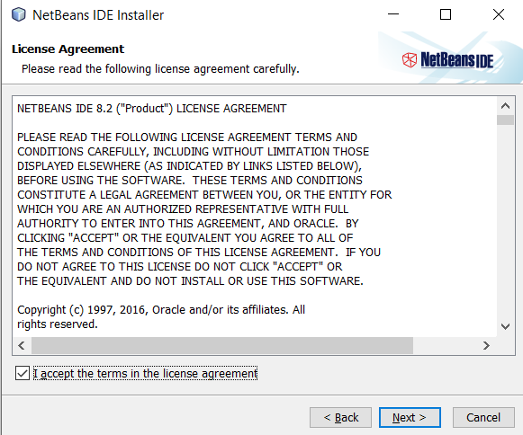

1.4 Choose jdk 1.8.0_291

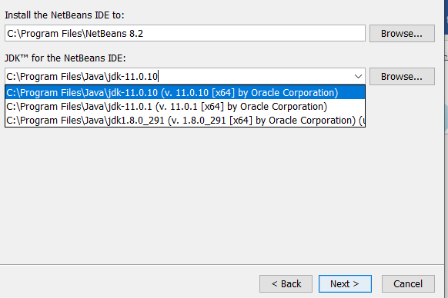

1.5 Click next

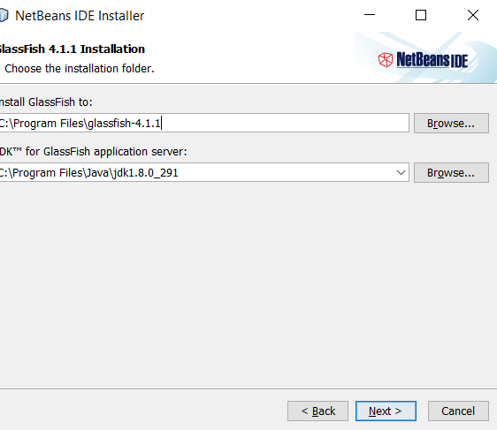

1.6 Click install and **please wait**

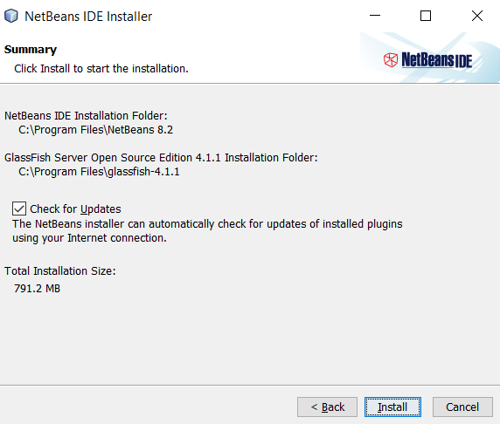

1.7 Click finish

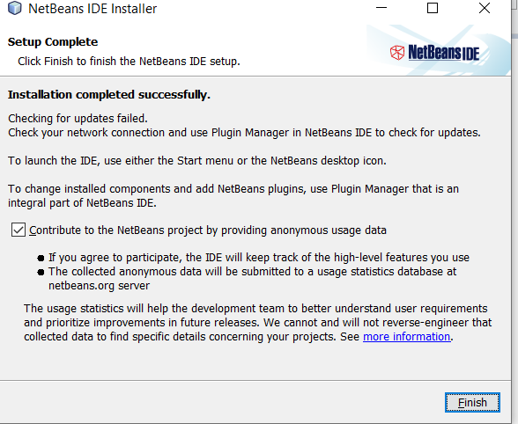

1.8 Open netbean 8.2.click no if dialog import show

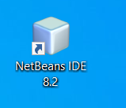

1.9 Click windows at top panel-> click service

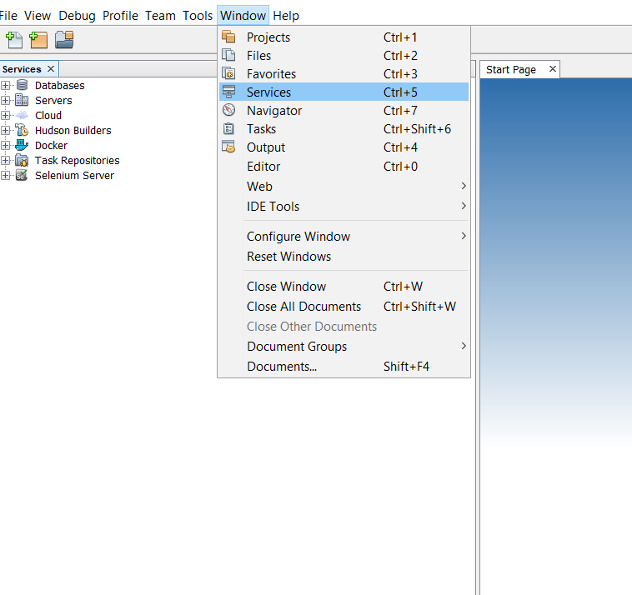

1.10 At left panel ,right click severs and click add sever

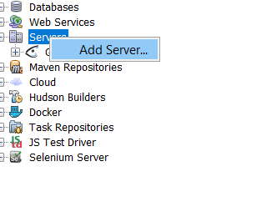

1.11 Choose glassfish server and click next

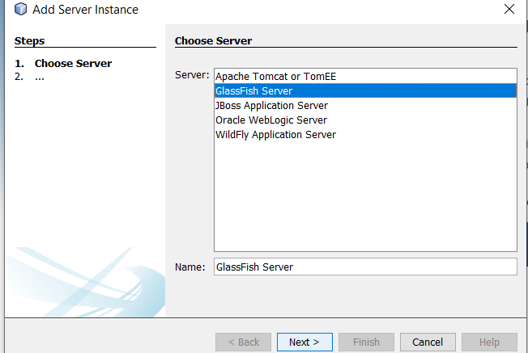

1.12 Click browser

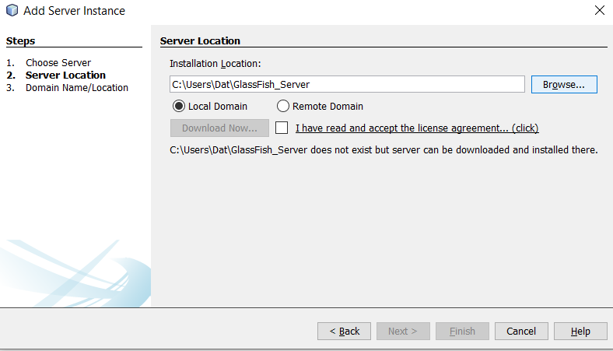

1.13 Choose location glassfish 4 and click choose

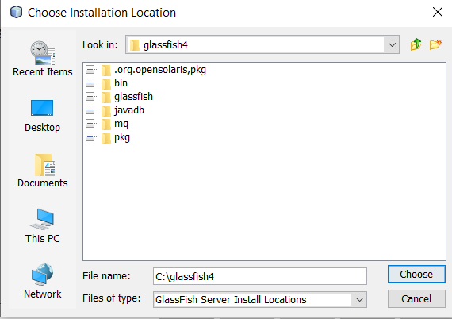

1.14 Click next

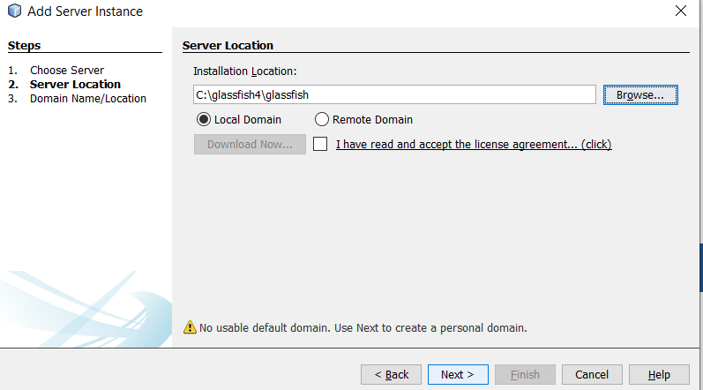

1.15 Click finish

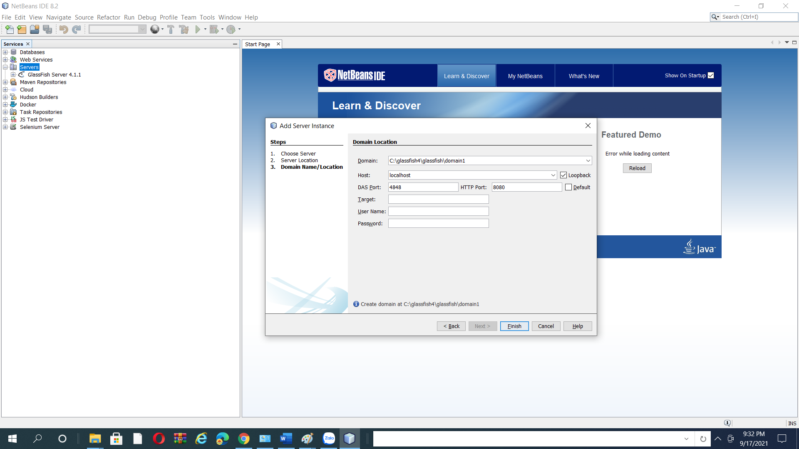

1.16 Open ssms and login Sql sever

1.17 Open file cinestar1.sql(inside folder database inside Group3_cinestar) and run script(Make sure CinestarDatabase don’t exist).If error,please drop database CinestarDatabase and then run file cinestar2.sql (inside folder database inside Group3_cinestar)

## Step 2 Deploy sever

2.1 Click file->click open project

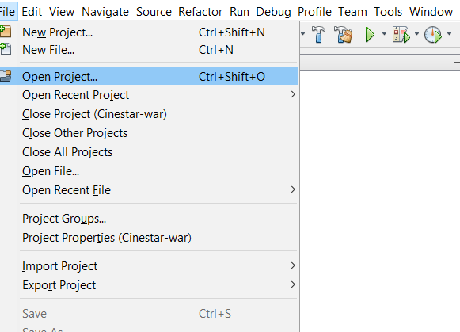

2.2 Unzip Cinestar in folder Sourcoce in folder Group3_Cinestar or at github . Find location project and click Open project

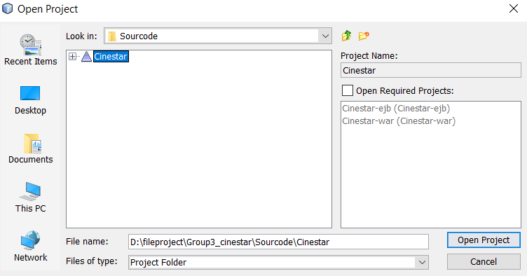

2.3 At left panel,click to services

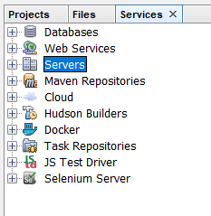

2.4 Double click servers,right click glash fish server and then click Start

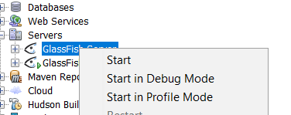

2.5 Wait and then Right click again.Then, click View domain admin console

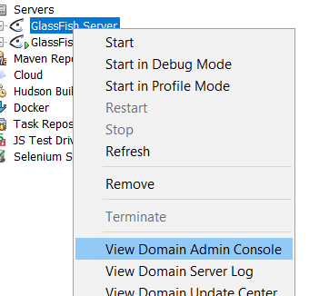

2.6 Glassfish console will show in browser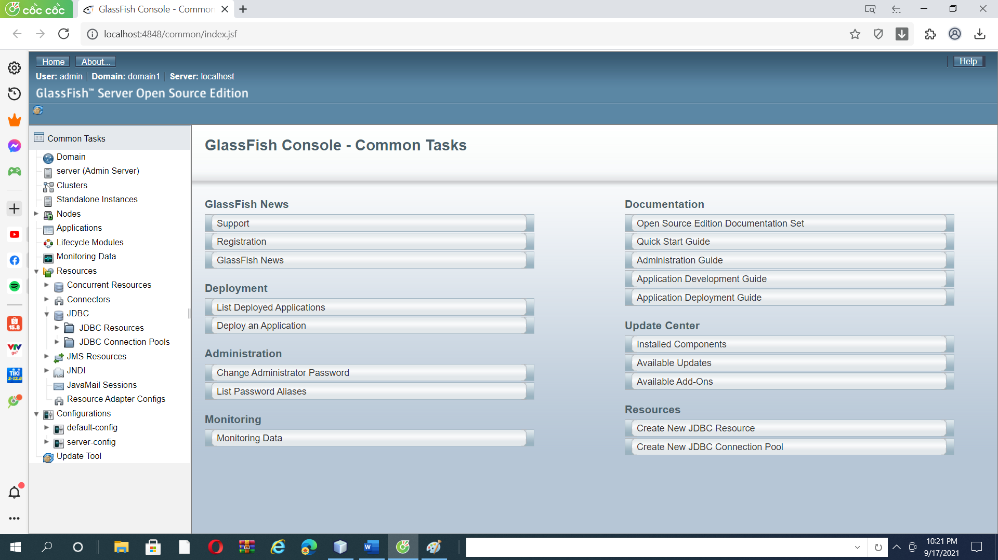

2.7 At left panel.click jdbc Connection

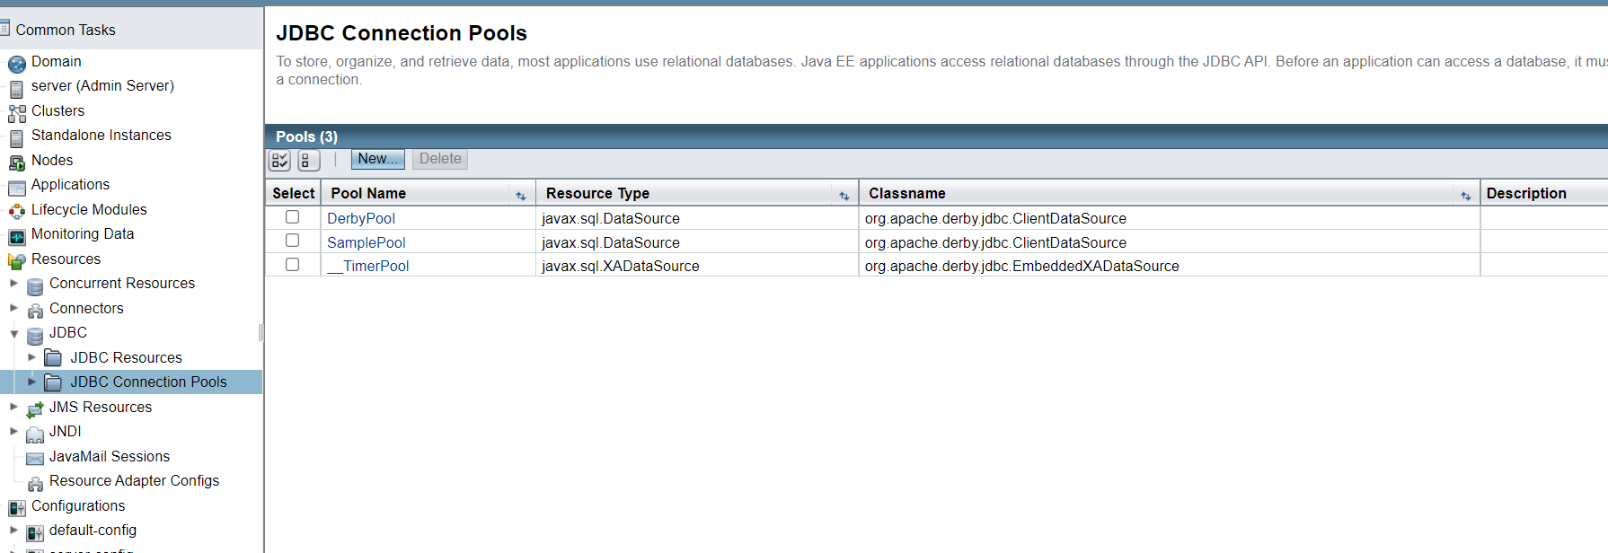

2.8 click new

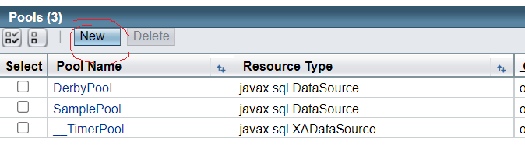

2.9 Input poolname uptoyou,resource type choose javax.sql.DataSource. Datebase Driver vemdor choose MicrosoftSqlServer

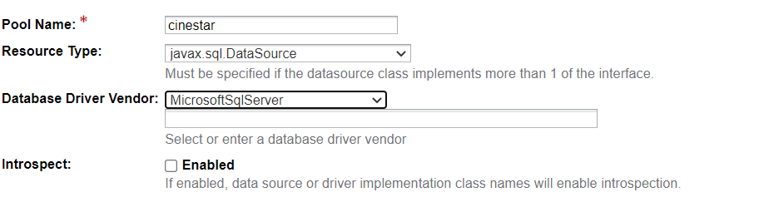

2.10 click next

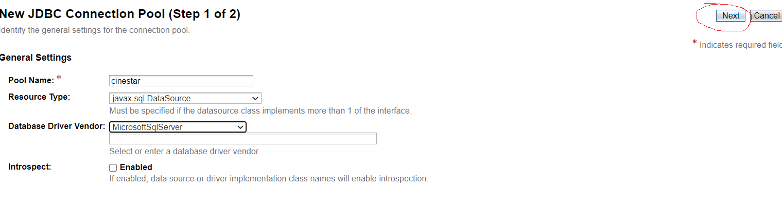

2.11 fill user connect database next user

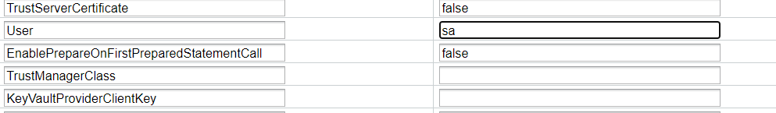

2.12 fill password connect datbase next Password



2.13 fill CinetarDatabase next DatabaseName



2.14 click finish



2.15 choose pool you have created



2.16 Click ping to test

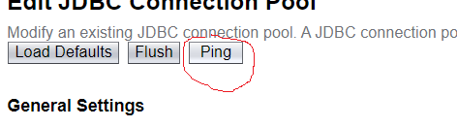

2.17 At left panel, click jdbc resources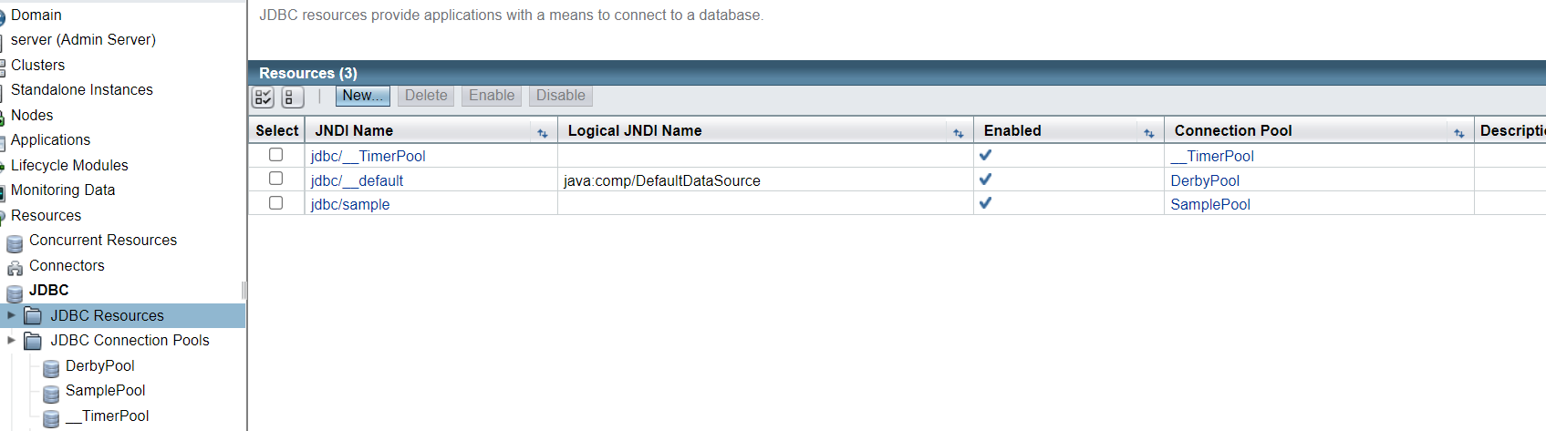

2.18 Click new

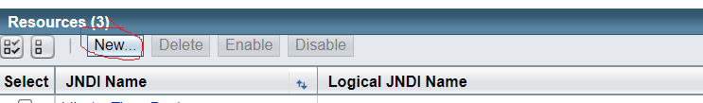

2.19 input jdbc/cinetarts next JDNI NAME.choose pool you have created at poolname

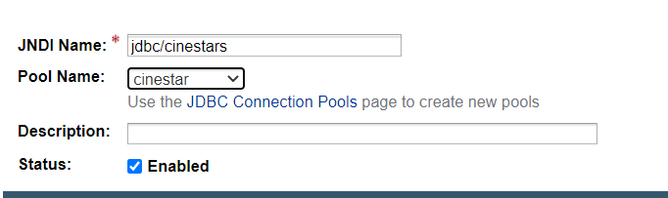

2.20 Click ok



2.21 Click project at top left panel. Open project. It still not open

2.22 Double click Cinestar, double click cinestar-ejb,jar

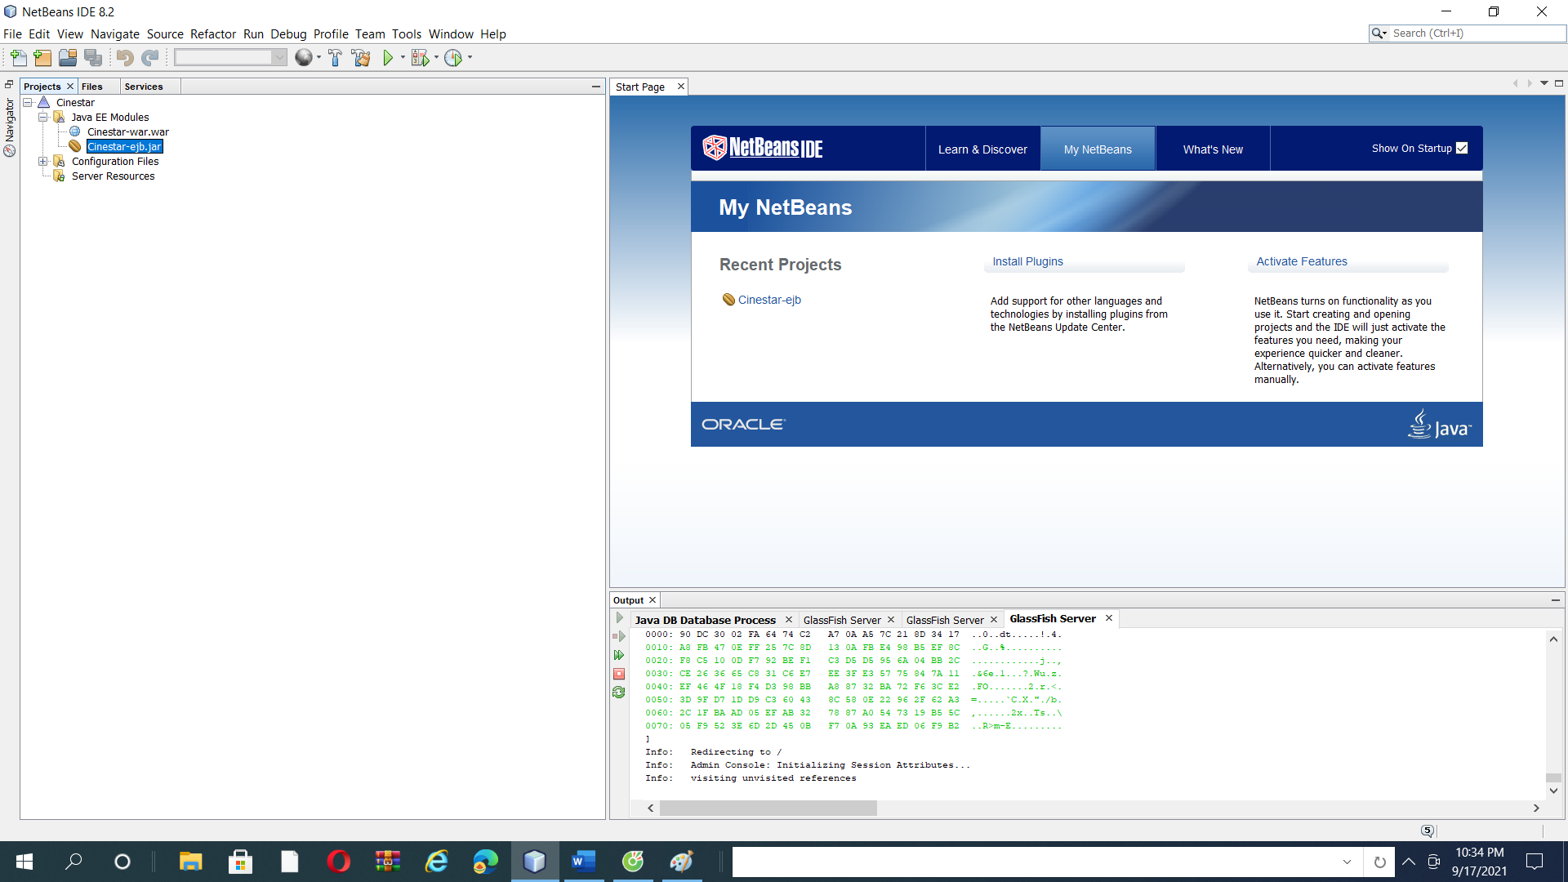

2.23 Right click Cinestar-ejb.jar below

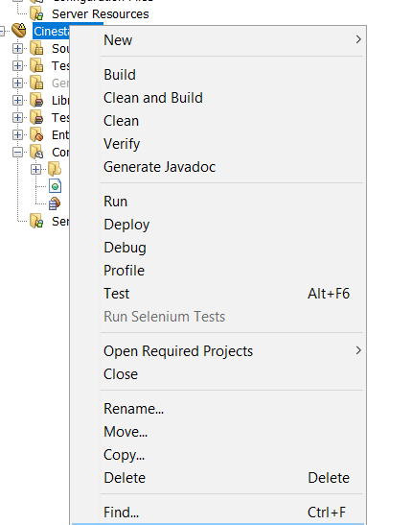

2.24 Choose resolve data source problem

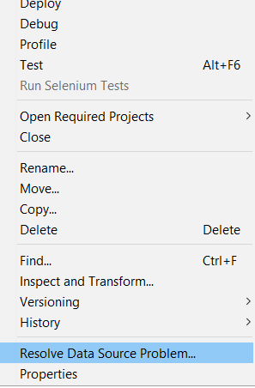

2.25 click Add connection

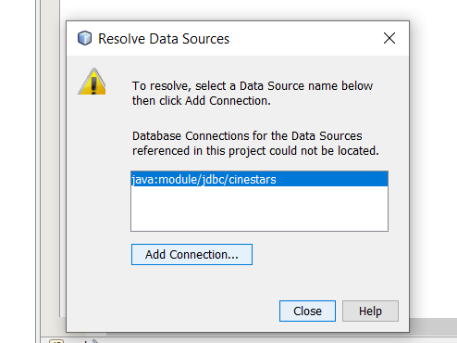

2.26 click add

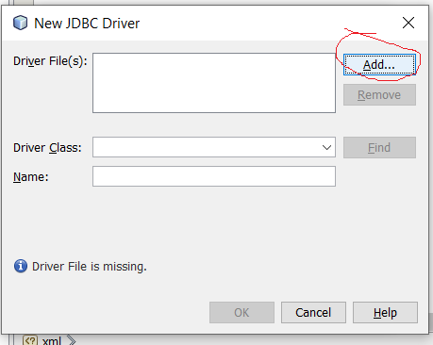

2.27f ind location mssql-jdc-9.4.0.jre8.jar(glasshfish4->glasshfish->lib) and click open You can Down load mssql-jdc-9.4.0.jre8.jar at https://docs.microsoft.com/vi-vn/sql/connect/jdbc/download-microsoft-jdbc-driver-for-sql-server?view=sql-server-2017.

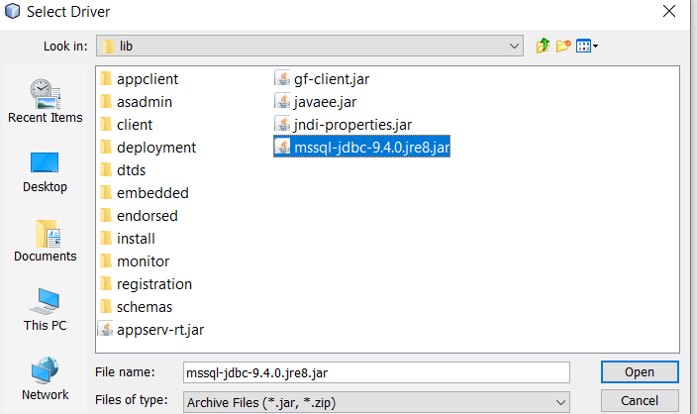

2.28 click ok

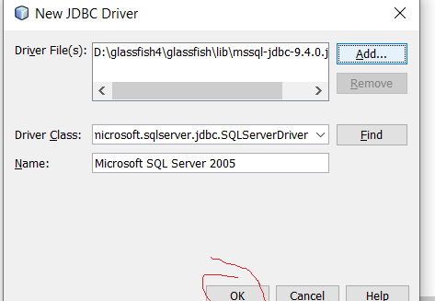

2.29 Enter uername,password

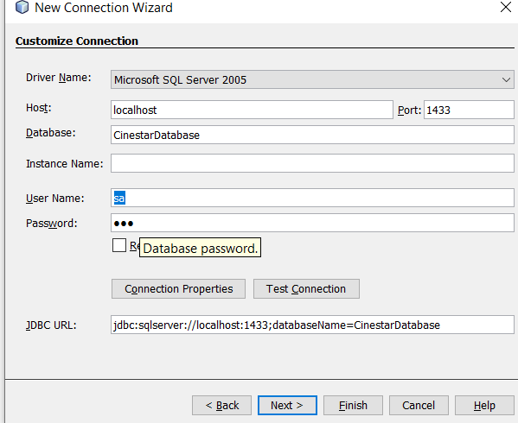

2.30 Click test connection.It ‘s ok.Do next step. If isn’t ,try again

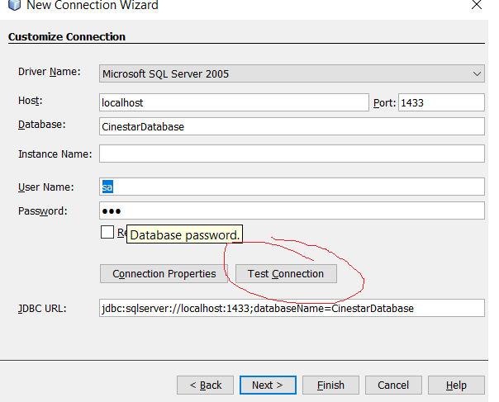

2.31 Click next

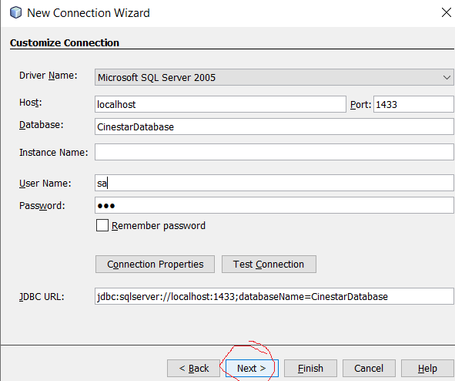

2.32 choose dbo

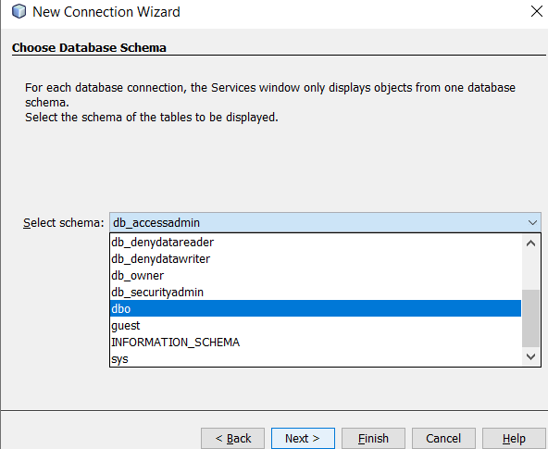

2 .33 click finish and PLEASE WAIT and then close

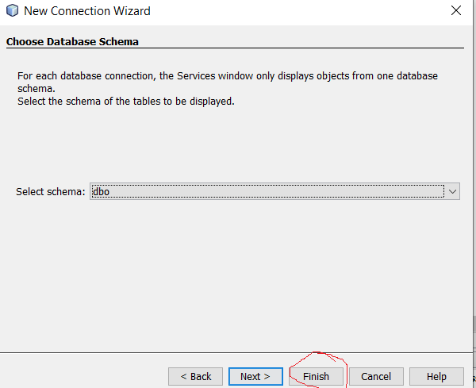

2.34 Right click cinestar-ejb and click deploy

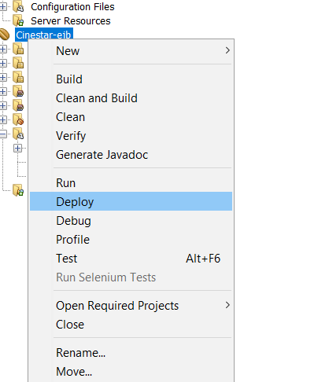

2.35 click use this installation and PLEASE WAIT

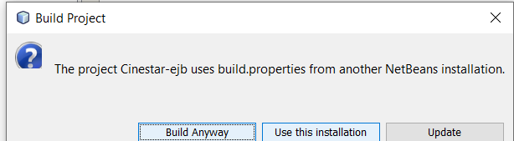

2.36 Build success

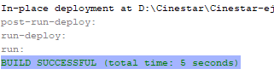

## Step 3 Add jar and fix web client and run project

3.1 At Cinestar double click cinestar-war.war

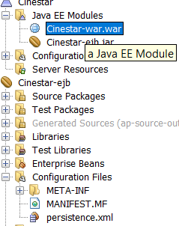

From 3.6 to 3.8, you don’t need to do

3.2 Click resolve problems

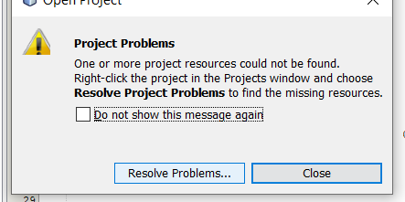

3.3 Click resolve

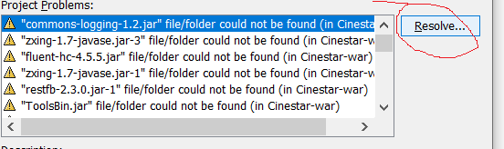

3.4 Find folder lib in Group3_cinestar and choose jar correspond to warning name.Example:g-son-2.8.2.jar “file/

Folder could not found->choose g-son 2.8.2

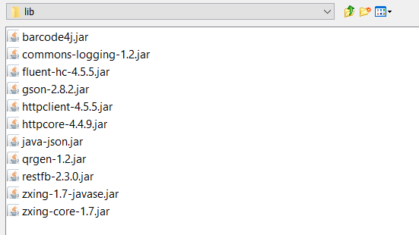

3.5 Repeat 3.4 until no have warning

3.6 Click to webpage and click file with have css parsing error at webpage.Example asstes->css->argon.css

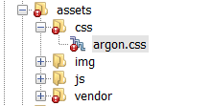

3.7 find line have light bulb and click light bulb

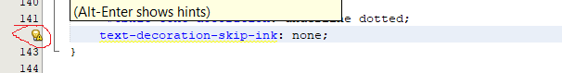

3.8 click seond line(Filter out css partsing eror

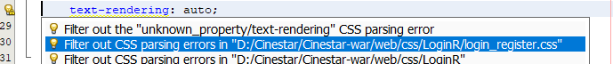

3.9 Right click libraries

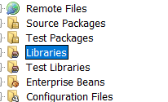

3.10 Double click Add jar/folder

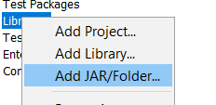

3.11 find folder lib in Group3_cinestar and click all jar

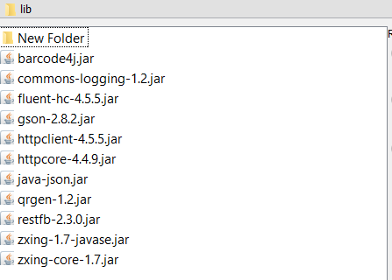

3.12 click open

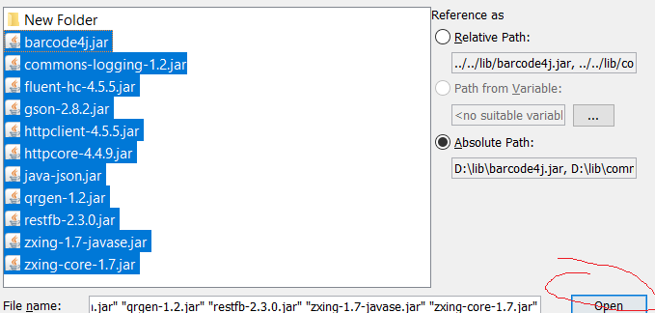

3.13 right click cinestar and then click run and PLEAE WAIT

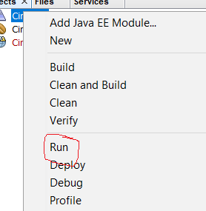

3.14 Success

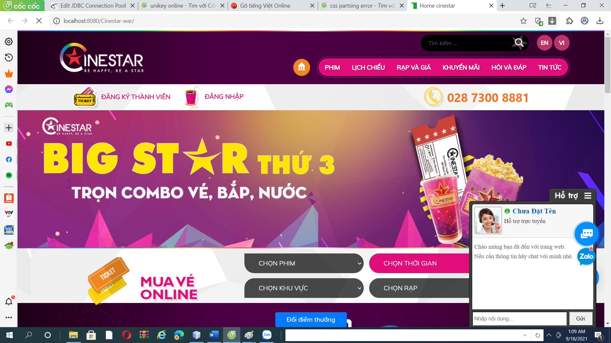

3.15 if you got error Yourpath\Group3_cinestar\Cinestar\nbprojcet\build-impl.xml:208. Please click second blue line



3.16 Remove copyfile from 1006 to 1027 and copyfile from1032 to 1053

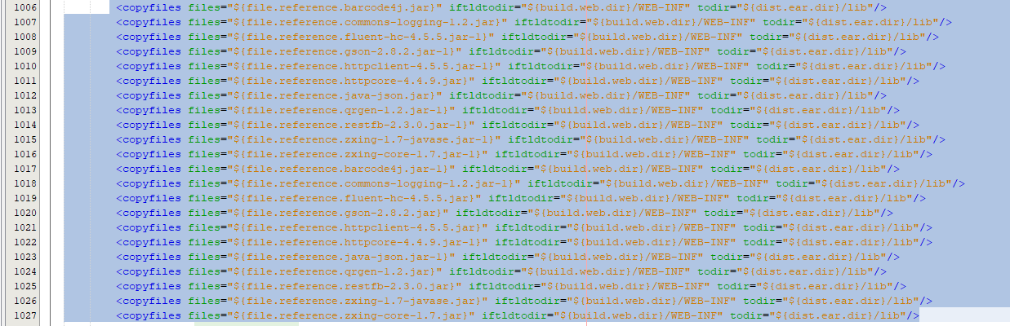

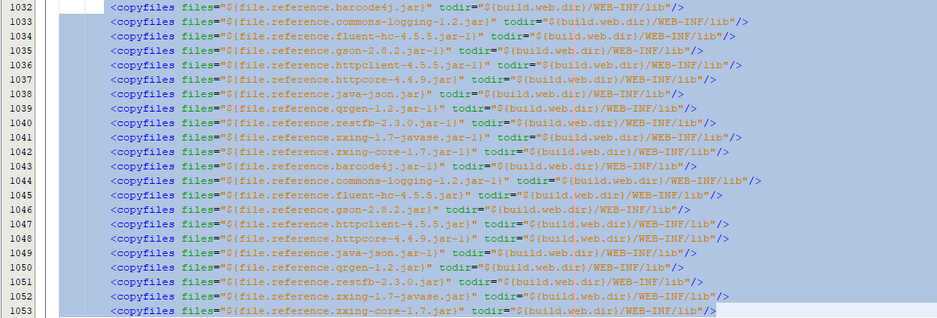

3.17 Save(Ctrl+s) and run again

# ANDROID

## Step 1 Install and run sever(api spring boot)

1.1 Downlod intellij at <https://www.jetbrains.com/idea/download/>. Choose download **Ultimate**

1.2 Run ideaIU

1.3 Click next

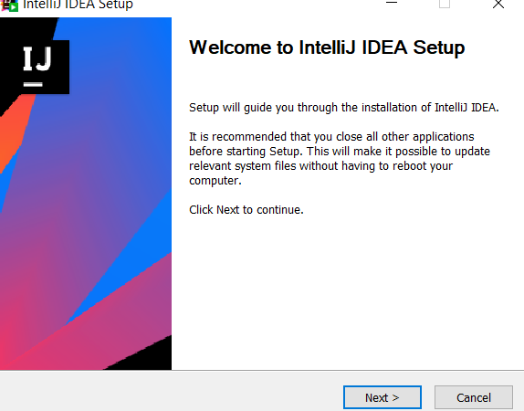

1.4 Click Browse to choose location install and click next

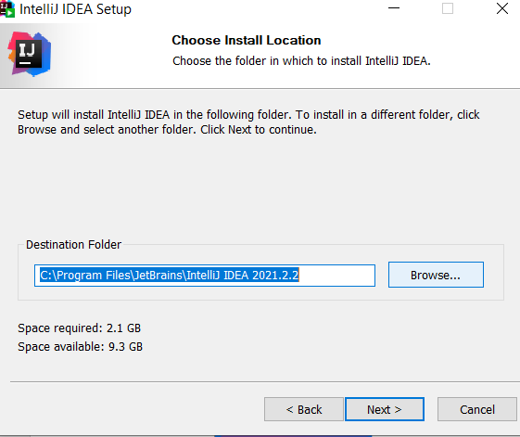

1.5 Choose all and click next

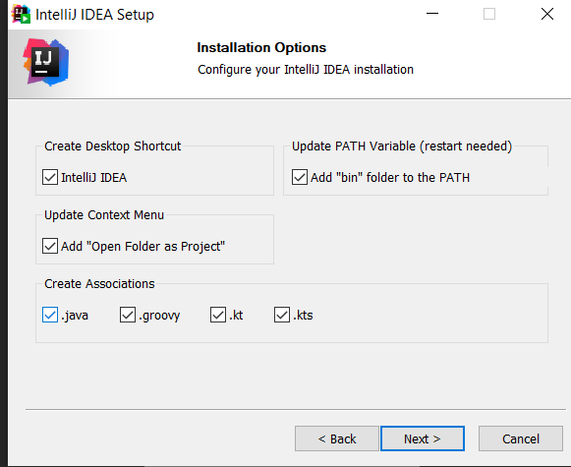

1.6 Click install and PLEASE WAIT

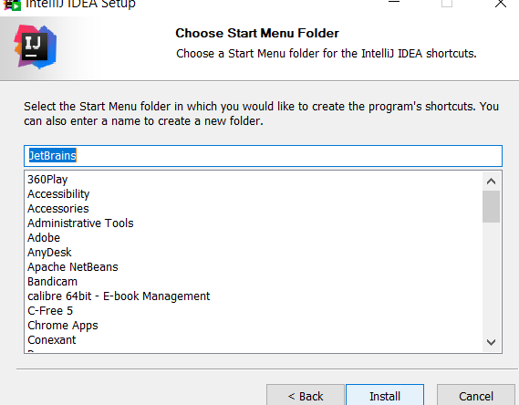

1.7 Run INtellij

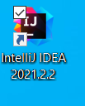

1.8 Click circle next evaluate for free

1.9 Click Evalute

1.10 Click continue and run intellij idea again(1.7)

1.11 Click open

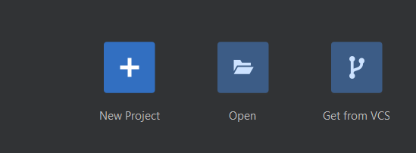

1.12 Unzip demo1(Inside folder Soucode inside folder Group3_Cinestar). Find location demo1 and click ok

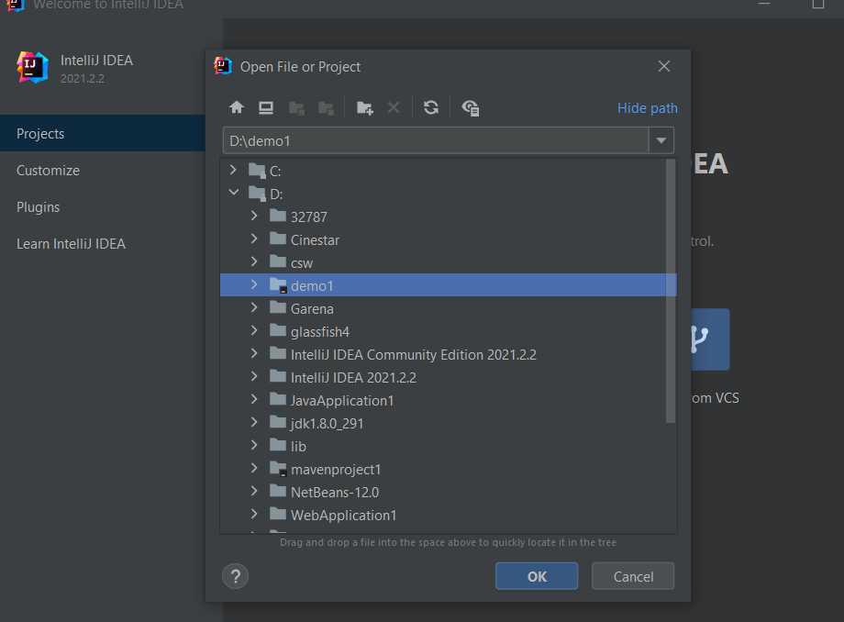

1.13 Please wait to load.Then, click trust project

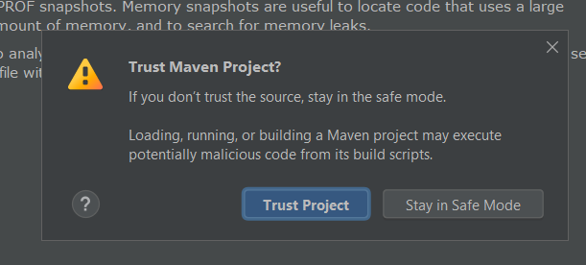

1.14 Click close

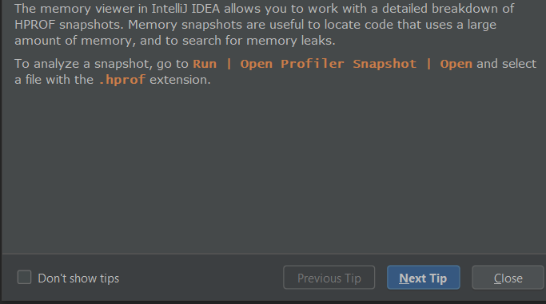

1.15 Click project left panel

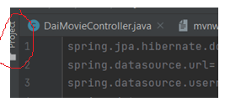

1.16 Double click demo1->double click src->double click resources->double click application.properties

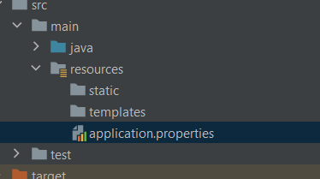

1.17 Change username and password your connect database

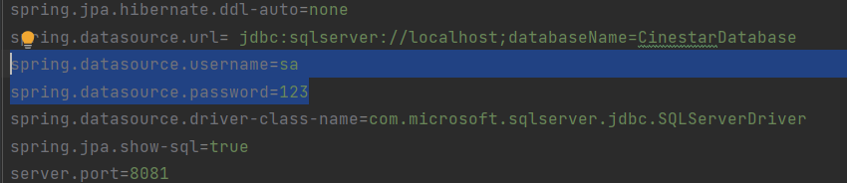

1.18 Click run at top toolbar



1.19 Click run

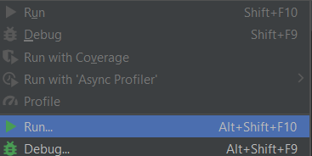

1.20 Choose Demo1Application and click

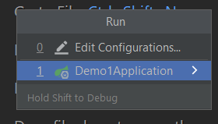

1.21 If have error below,please wait 5-10 minutes and then run again



1.22 Start success. It still have error,please continue wait 5-10 minues and run again.



## Step 2 Install android studio and run project

**You must run sever before launch app**

2.1 Run android-studio-ide-202.7486908-windows.exe

2.2 Click next

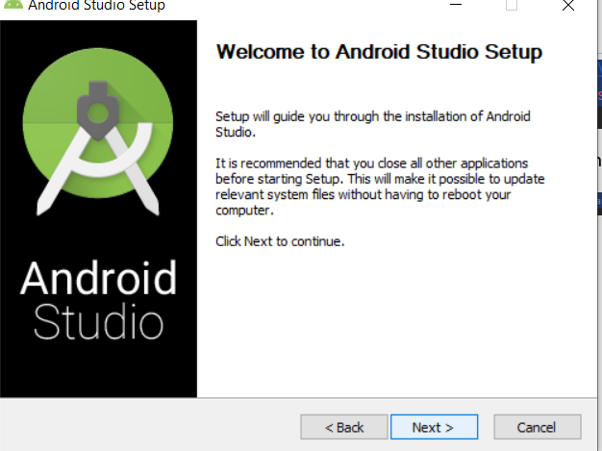

2.3 Click next

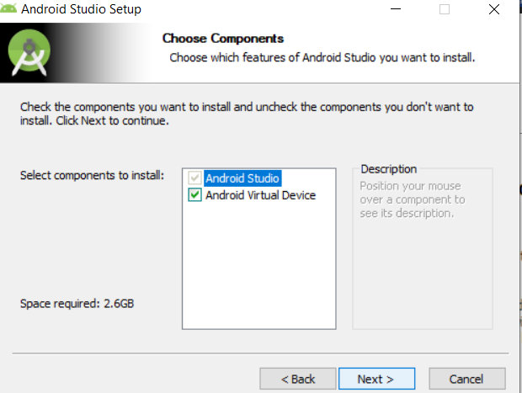

2.4 Click Brose.. to location install and click next

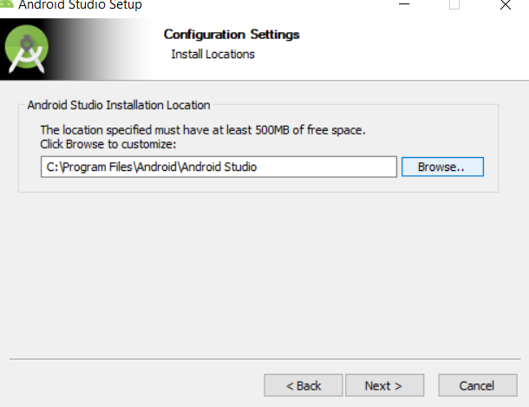

2.5 Click install

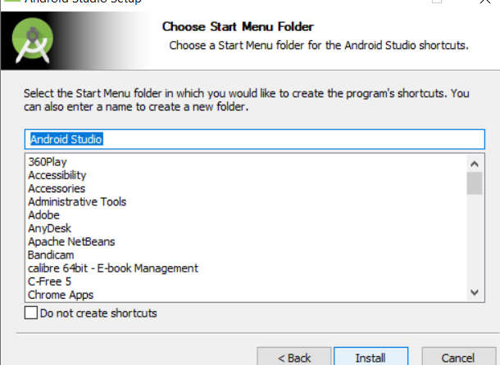

2.6 Click next

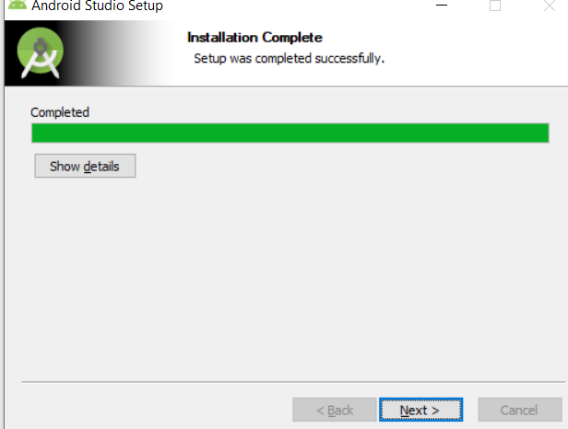

2.7 Click finish

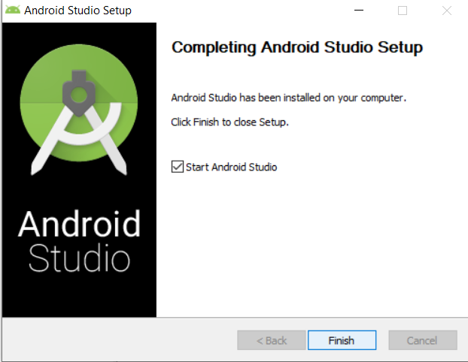

2.8 Click don’t import setting(if dialog show)

2.9 Click don’t send

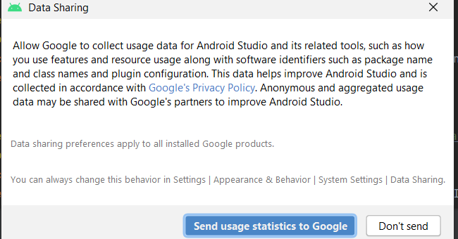

2.10 Click next

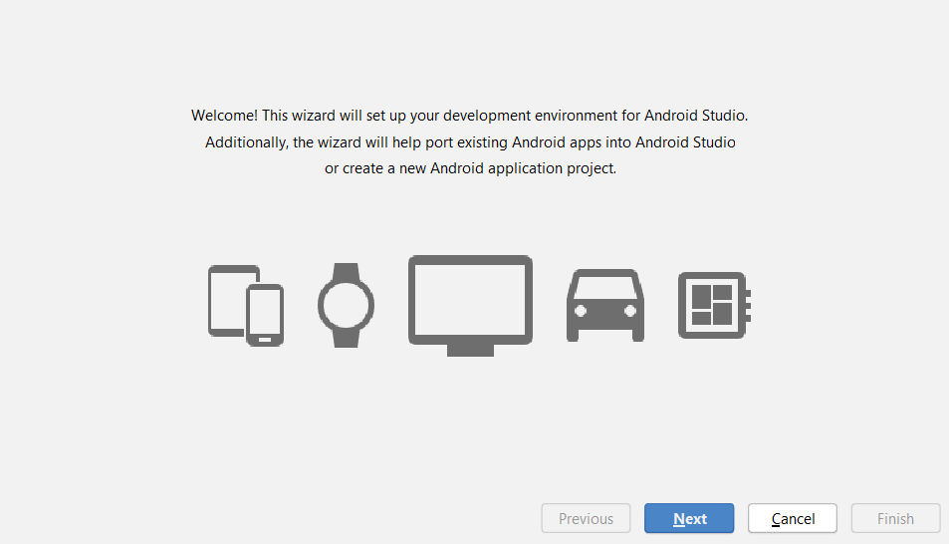

2.11 Click next

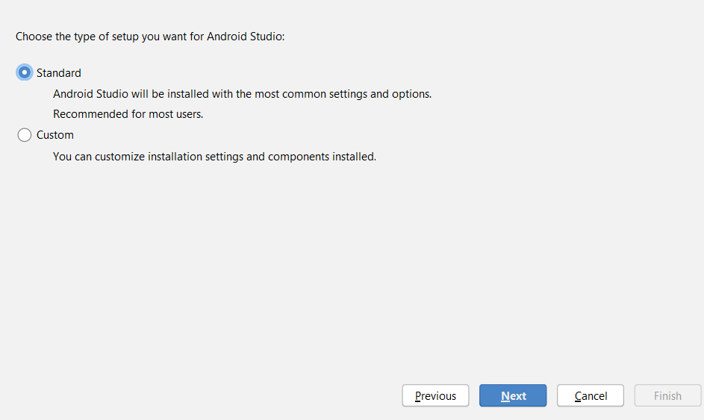

2.12 Choose Darcula or light and click next

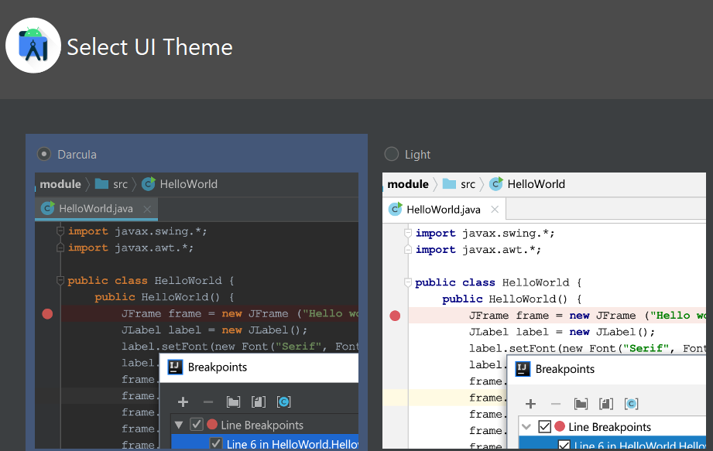

2.13 Click finish

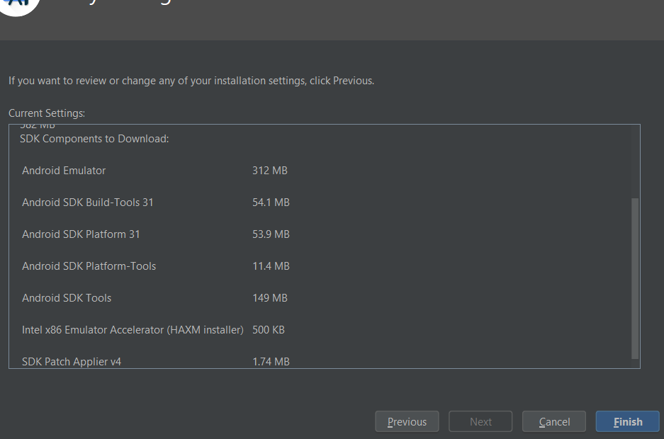

2.14 Please wait and then click finish

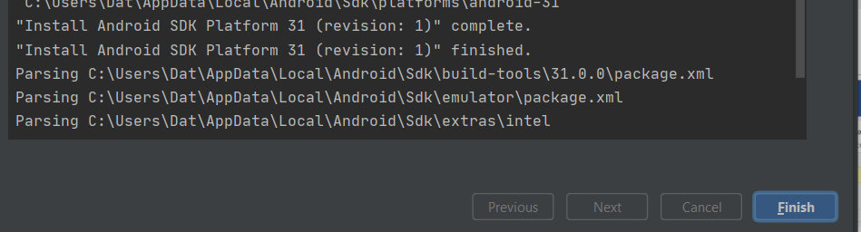

2.15 Uzinp myapplication3(inside folder Sourcode inside folder Group_Cinestar). Click open an existing project and Open myapplication 3

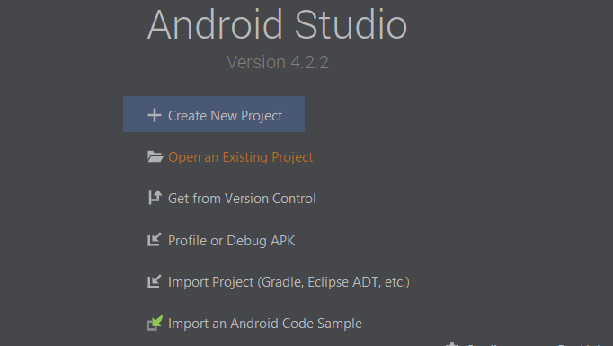

2.16 Click ok

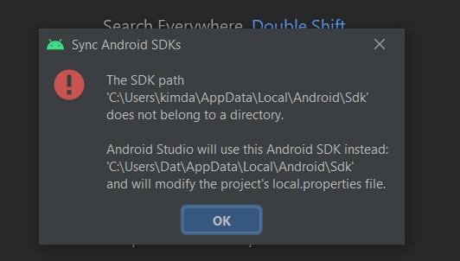

2.17 Click AVD Manater at top right

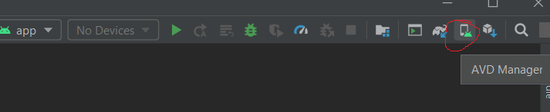

2.18 Click create virtual device



2.19 Choose emulator and click next

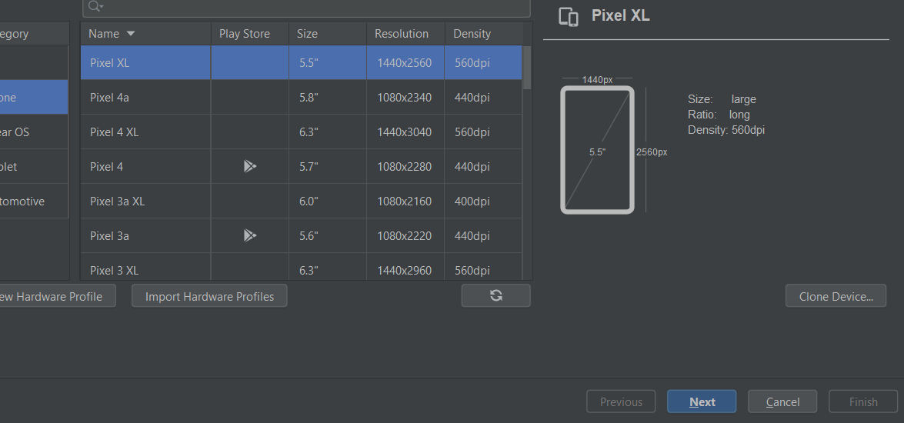

2.20

a.Choose api level(download if need) and click next

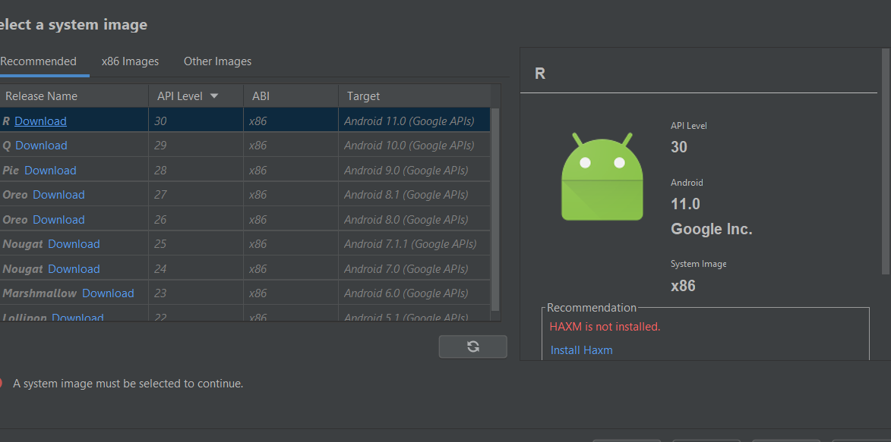

b. When dowload, choose accept and then next

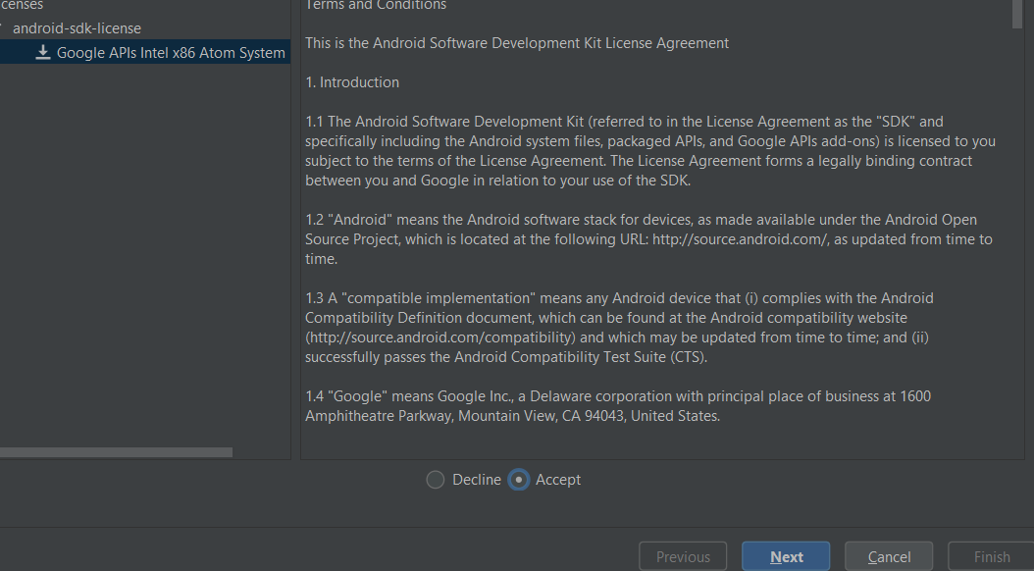

c. When download completed, click finish

2.21 Click finish

2.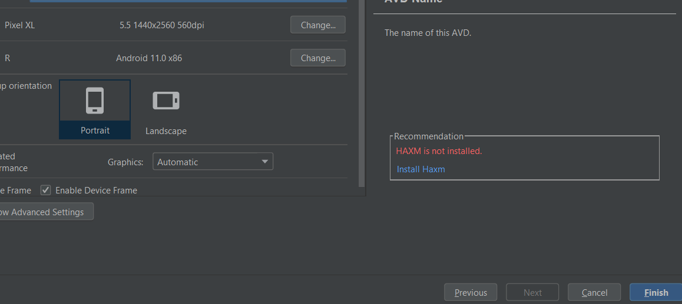

2.22 Click runapp at top toolbar

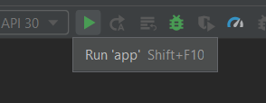

2.23 Start successfully

2.24 If you get error the process killing by…, please install another emulator(from step 17)

2.25 If you can meet error Caused by: org.gradle.api.internal.plugins.PluginApplicationException: Failed to apply plugin 'com.android.internal.application', please do step 2.26 to 2.28  


2.26 At left panel,double click gradle.properties

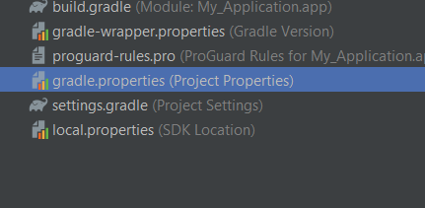

2.27 copy android.overridePathCheck=true next line android.useAndroidX=true

2.28 Hover to text android.overridepathCheck=true until light bulb appear.Click to light buld

2.29 click syns now or try again and then start again (2.22)  
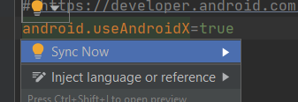

2.30 If you got error sdk location not found, please do step 2.31 to 2.38



2.31 Create new project.File->new->project

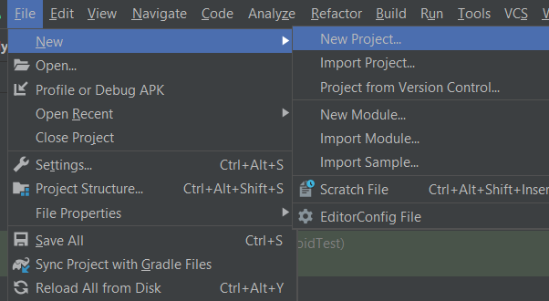

2.32 Choose empty activity and click next

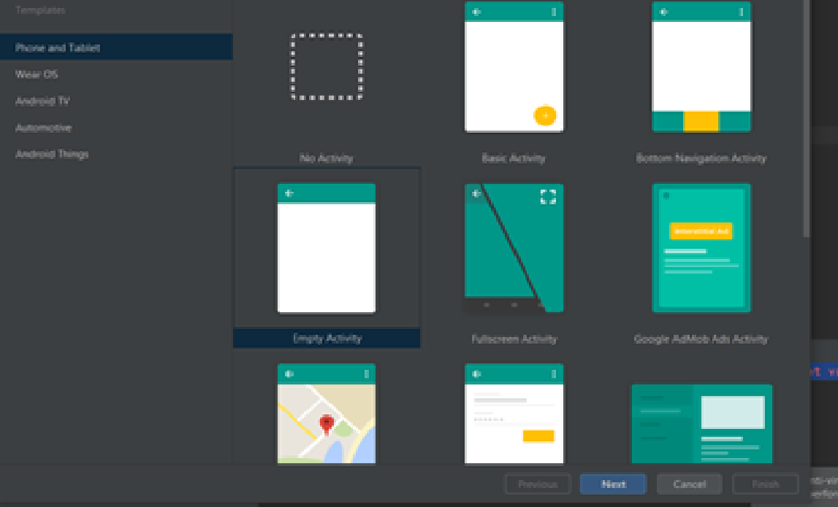

2.34 Click finish and wait new project start

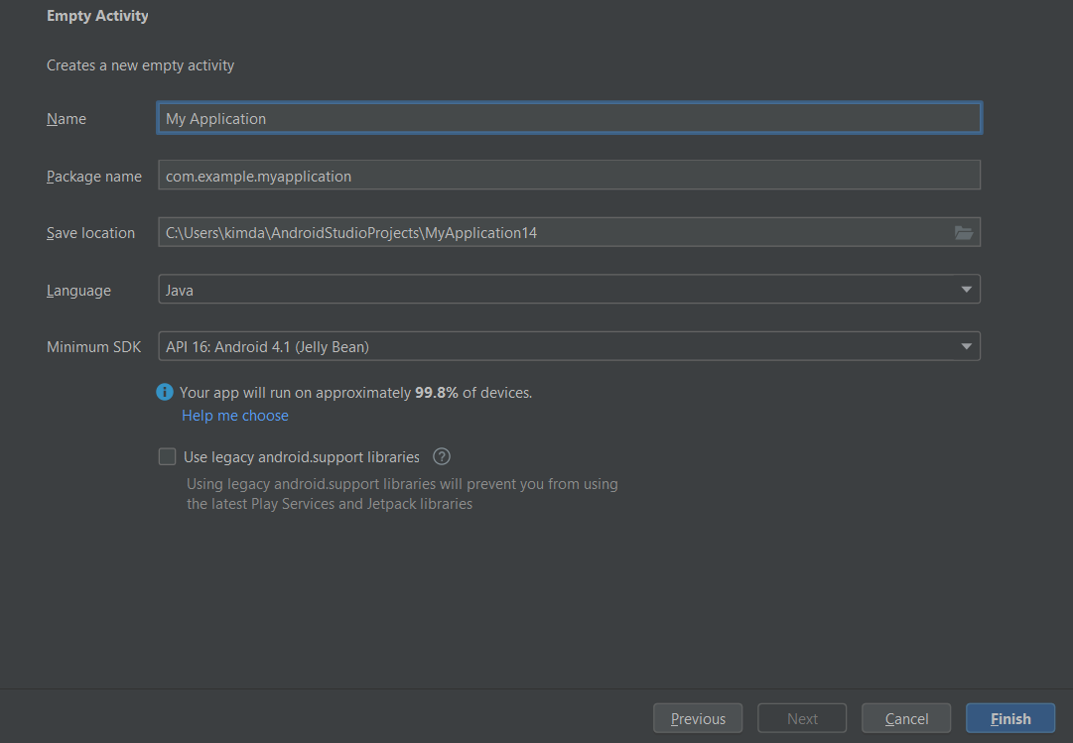

2.35 At left panel,when Grale scripts show,double click gradle scripts -> double click gradle.properties

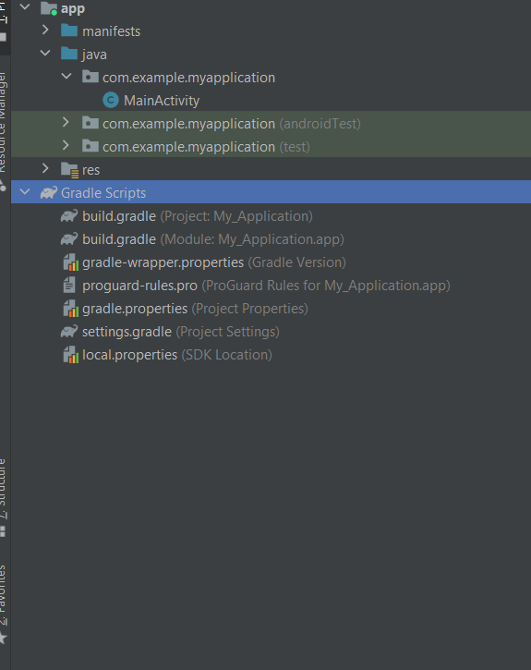

2.36 At ocal.properties copy text at line 10.Example sdk.dir=C\:\\Users\\kimda\\AppData\\Local\\Android\\Sdk

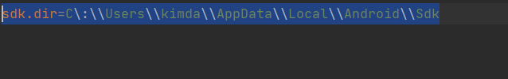

2.37 Go back prev Project and at prev project.Do step 2.35 at prev project

2.38 At line 10,change line 10 into your text have copied at 2.36. Then,start again

